Renju lesson on May 10, 2001

Hello all! Welcome to Online Renju Class. We will continue our study about d11. It is the hardest opening, but yet so important for us. We need to learn everything about it if we want to be better than others.
Today our first choice of 14th move is j8. Does anyone of you already know how to play here? Try to guess. It is similar to 14-j7 style. Well, we cant play too passively here, otherwise white wins on the left side. 15-L9, 17-k8.
K8- correct. Now, White has two choices.
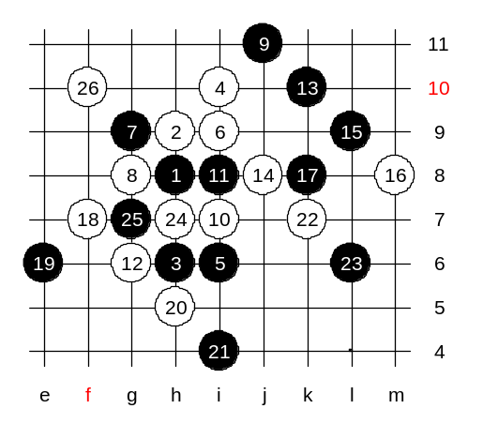
Lets study both of them. First, lets look at f7 and h5. After the 21st move, white has got the tempo. Can white attack now? And how? Do you agree that black material is powerful enough so that in case white fails the attack then black wins easily. So, all we have to do is to check whether white can do anything or not. K7 now – this is the only way to continue white attack. Now, after 23-L6, does black have VCF threat? Yes. So, white cannot attack on left or upper side. White must play somewhere around black’s VCF area. The most interesting move is h7. Try it. The idea is to threat to the 3x3 at h7, and block black’s VCF below at the same time. What should black do about it? As you see, 25-g7 loses.
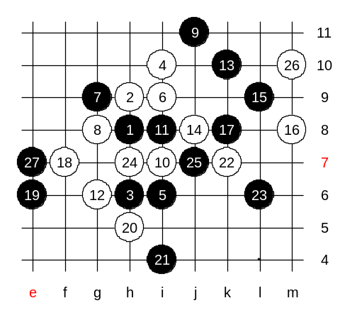

Black was forced to play a four to j7. And now after e7 black has 3 powerful areas – left, upper and lower area. Please also consider 27-g11. If it is possible then it is better than e7.

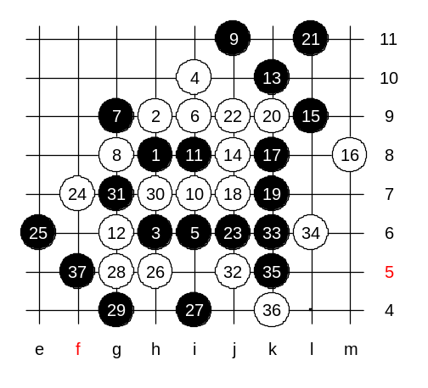
Now, we study the 18-middle. The variant looks a bit similar with last week one.
Those who found 21-L11 were right. It is an important timing.
White could play the fours below, but it is quite meaningless, therefore white just blocks in the middle. White should try to attack now. Moves f7 and h5 are the beginning of the attack. Can white win? How to block?
White has finally failed the attack and black wins easily now.
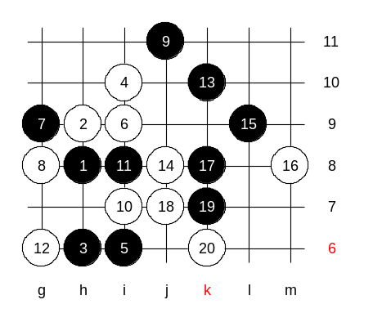

This is medium level homework.
Please find the black win.

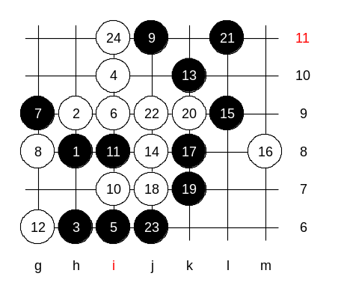

This is the advanced level homework.
Please find the black win.

